Use Case Realisation Report (Analysis) - Review Project Experience
FOR
Volunteer Management System
(VMS)

CLIENT
PROJECT | Volunteer Management System (VMS)
TITLE | Use Case Realisation Report (Analysis) - Review Project Experience
VERSION | 0.3a0.2a
DATE | 14-Aug-2011
 | ORIGINATOR
 | Name / Signature | Team 8S
 | APPROVAL
 | Name / Signature | Phung Kim Cuong, Dio
Institute of Systems Science |  | Document Reference
25 Heng Mui Keng Terrace  Singapore 119615 |  | VMS/T-1.4.1/1

 | Acceptance
 | Customer Signature |  | Customer Signature
 | Name & Designation |  | Name & Designation
 | Date & Company Stamp |  | Date & Company Stamp

Revision History

Date | Version | Description | Author
12-Jun-2011 | 0.1a | Creation | Team 8S
12-Aug-2011 | 0.2a | Update | Team 8S
14-Aug-2011 | 0.3a | Update | Team 8S

Table of Contents

1. Brief Description 4
2. Flow of Events 4
2.1 Review Project Experience: 4
2.2 Exceptions 5
3. Interaction Diagrams 6
3.1 Collaboration Diagram for Review Project Experience 6
4. Participating Objects 6
4.1 Staff 6
4.2 Project Manager 6
4.3 Project 6
4.4 Feedback 6
4.5 FeedbackDetailScreen 6
4.6 HomeScreen 7
4.7 MainController 7
4.8 FeedbackController 7
5. Class Diagrams 7
6. Derived Requirements 7
ANNEX D Amendment History 8

Use Case Realisation Report (Analysis) - Review Project Experience

Brief Description
The use case enables a Project Manager to review the list of user posted experience regarding the projects under him and decide whether to publish the user-content.

Flow of Events
The standard flow of events for this use case and any exceptions are described in the following subsections. See section 3 for an overview of the participating Actors and Domain Objects.
Standard Flow
Precondition: User has logged in the system and the user role is project coordinator

Review Project Experience:
- The use case starts when the Project Manager selects the menu option from the HomeScreen. The HomeScreen. getProjectExperienceScreen() operation is triggered.
- The getProjectExperienceScreen() operation triggers the MainController.getCalendarMenu() which delegates to the CalendarController. reviewProjectExperience() operation.
- Then the MainController delegate to the FeedbackController.getProjectExperience() operation.
- The FeedbackController will then use the StaffController.getStaff() to get a staff profile,which in turn trigger Staff.getStaff().
- With the staff profile, the FeedbackController use the ProjectController.getProjectOfStaff() , which in turn will call the Project.getProject() to return a list of project under this Project Manager.
- With the list of project, the FeedbackController will call the Feedback.getFeedback() to return a list of all user posted project experience regarding the list of projects.
- FeedbackController will then show the list of feedback via the FeedbackDetailScreen.show() method
- The Project Manager now can review and decide whether to publish the content, which will trigger the updateFeedback() operation of the FeedbackDetailScreen.
- The updateFeedback() operation is in turn trigger the Feedback.update() to store the data. After that the FeedbackController will return a message via FeedbackDetailScreen.sendMessage().
- The use case terminate when the actor click Close button on the FeedbackDetailScreen, which trigger FeedbackDetailScreen.close() method.

Exceptions
The following exceptions were identified:
- Update fails. If the Feedback.update() operation fails, the feedback is not updated. An error message will be displayed in the FeedbackDetailScreen by the operation FeedbackDetailScreen.sendMessage().

Interaction Diagrams

Collaboration Diagram for Review Project Experience
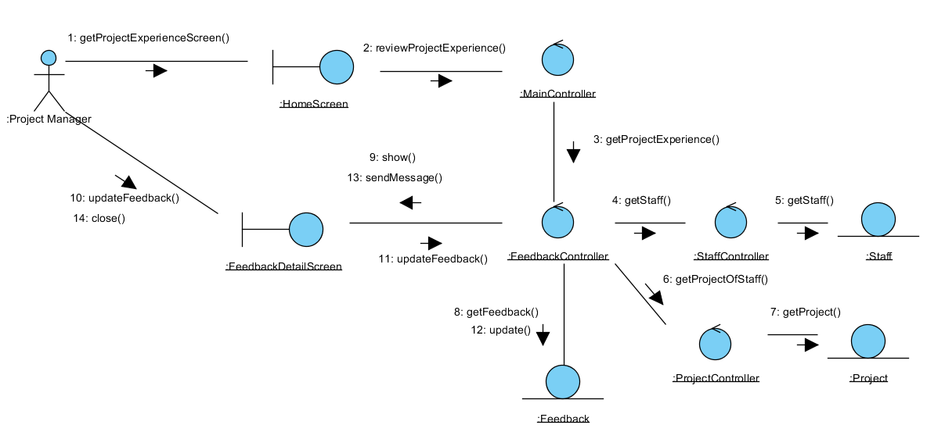
Figure 1 –Collaboration Diagram for Review Project Experience

Participating Objects

Staff
This entity object stores the details concerning a staff of the volunteer organisation. The primary attribute that it holds is the userID.

Project Manager
This is a Staff object type with a project manager role as an attribute.

Project
This entity object stores the details concerning a project of the volunteer organisation. The primary attribute that it holds is the projectID.

Feedback
This entity object stores the details concerning a user posted content inside the volunteer organisation.

FeedbackDetailScreen
This boundary object is used for displaying the details of user posted experience. Project manager interact with this object.

HomeScreen
This boundary object is used for redirecting and displaying of home screen details and menu. All the user actors use this object.

MainController
This control object co-ordinates the menu selection and dispatches of requests of the volunteer management system. It delegates the user requests to the specific use case control objects for carrying out the use cases.

FeedbackController
This control object co-ordinates the creation, update, viewing and searching of feedback in the volunteer management system. It receives requests from the boundary objects allocated for the specific purposes, along with all the necessary details required for the execution of these requests.

Class Diagrams
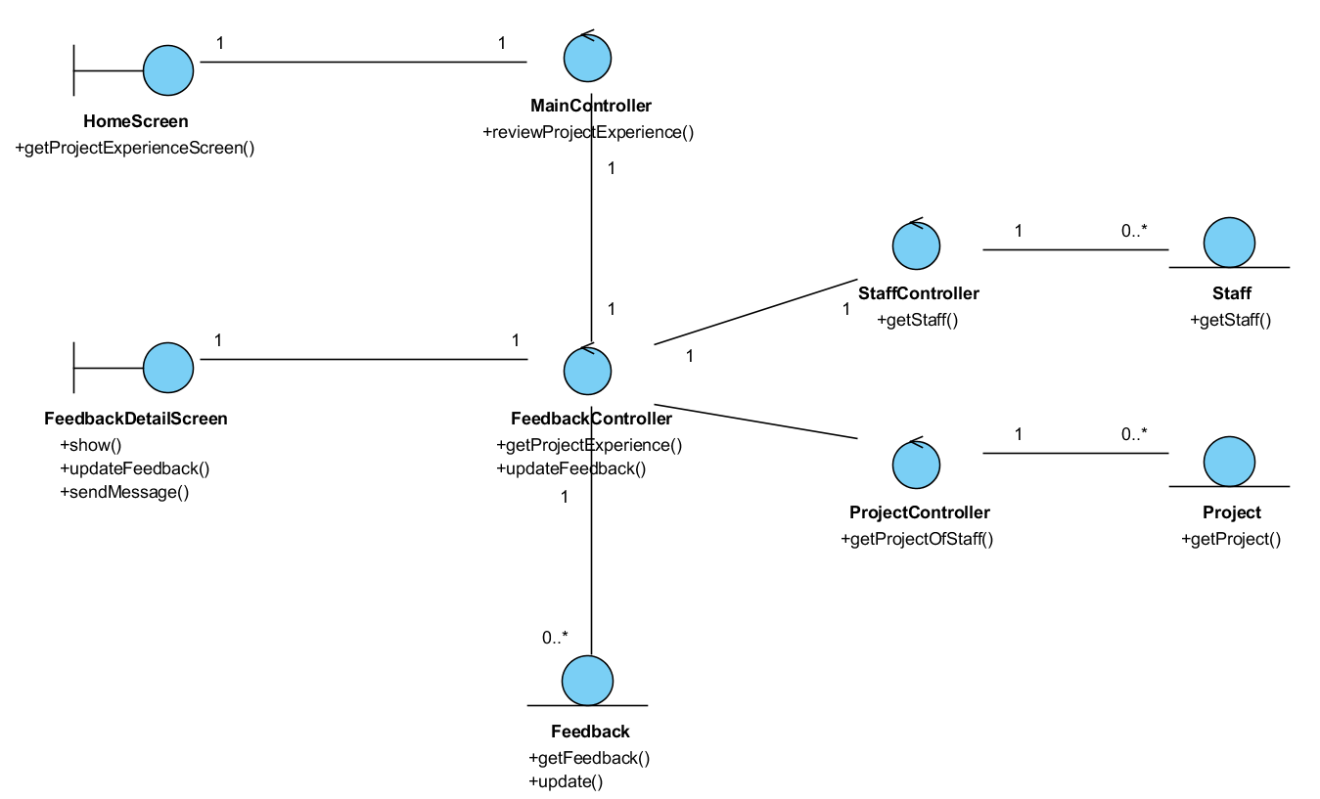
Figure 2 Class diagram

Derived Requirements
The Staff office PC (client system), keyboard and mouse will be used to process the project details and view all the system responses.

ANNEX D Amendment History

This is a record of all amendments made to the Document.
Version | Chapter / Section | Page No | Notes of Amendments or Changes
0.2a | All | All | - Update workflow format
0.3a | All | All | - Add class diagram  - Reformat document

